Contact: Tricia McGough, TW Marketing
+1.254.383.9700; tricia@twmarketing.net

FOR IMMEDIATE RELEASE
Visit StratEdge at International Microwave Symposium (IMS) 2021 Booth 1014

StratEdge Announces Increased Manufacturing Capacity of Small Outline Glass Sidewall Thermally Enhanced Packages for Power Semiconductors
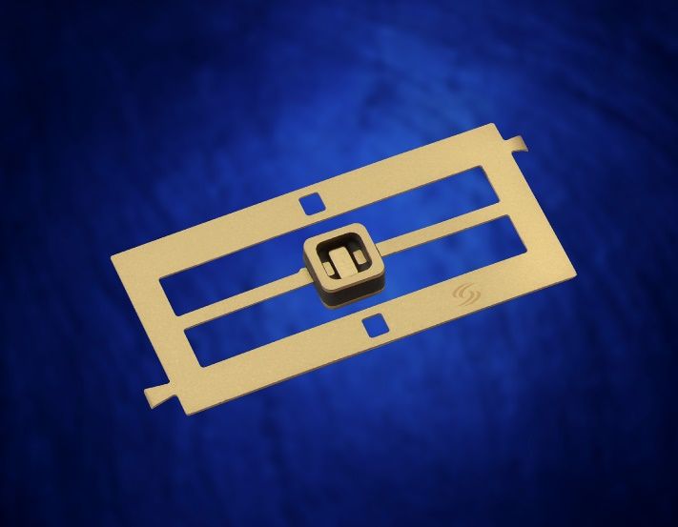
Santee, Calif. — March 10, 2021 — StratEdge Corporation, leader in the design and production of high-performance semiconductor packages for microwave, millimeter-wave, and high-speed digital devices, announces the increased capacity for manufacturing the small outline thermally enhanced alumina/glass sidewall packages for power semiconductors. The increased capacity is in direct response to increased requests for the product line. The new line of packages can be used for silicon, silicon carbide, gallium nitride, and other compound semiconductors in power integrated circuit applications. Specific devices include amplifiers, discrete transistors, and diodes where greater than 0.5 Watt power is consumed.

These thermally enhanced packages are designed for reliability and to mitigate the inherent stresses of brazing dissimilar materials together. All materials used in the packages have matched coefficients of expansion. They are assembled using a glass-to-metal seal process combined with gold germanium brazing, resulting in a rugged and reliable package. The packages can handle temperatures up to 360 degrees Celsius. A hermetic seal provides enhanced reliability for the device and offers protection from harsh environmental conditions, meeting military standard requirements. Packages in this series are sealed with metal or ceramic lids that have gold-tin solder preforms.

“These packages incorporate copper composite bases or copper inserts for enhanced thermal dissipation,” said Casey Krawiec, VP of global sales for StratEdge. “Devices are mounted directly to the metal bases thus providing excellent electric ground to the backside of the chip. They provide superior electrical performance for frequencies up to at least 6 GHz. For controlled impedance devices, transition designs with higher frequency performance can be utilized.”

Packages are available in various shapes, sizes, and lead counts. All can be provided with gull wing-shaped leads for surface mounting. A popular package is the two lead GW1010CT-1 that has a thermally enhanced copper tungsten base, supplied with copper insert. The GW1010CT-1 has a 0.100 inch square (2.5mm square) outline with a die attach area of 0.030 inch (0.76mm) by 0.055 inch (1.40mm) die attach area.
Photo available at https://www.stratedge.com/glass-sidewall.packages.png
Visit StratEdge at International Microwave Symposium (IMS) 2021 Booth 1014

About StratEdge
StratEdge Corporation, founded in 1992, designs, manufactures, and provides assembly services for a complete line of high-frequency and high-power semiconductor packages operating from DC to 63+ GHz. StratEdge offers post-fired ceramic, low-cost molded ceramic, and ceramic QFN packages, and specializes in packages for extremely demanding gallium arsenide (GaAs) and gallium nitride (GaN) devices. Markets served include telecom for 5G, VSAT, broadband wireless, satellite, military, test and measurement, automotive, clean energy, and down-hole. All packages are lead-free and most meet RoHS and WEEE standards. StratEdge is ITAR registered and an ISO 9001:2015 certified facility located in Santee, California, near San Diego.
###
For more information contact:

Casey Krawiec
StratEdge Corporation
9424 Abraham Way, Santee, CA 92071
Email: c.krawiec@stratedge.com
Phone: +1.858.569.5000

Tricia McGough
TW Marketing (agency)
Email: tricia@twmarketing.net
Phone: +1.254.383.9700

