6
Contact: Tricia McGough, AR Marketing, Inc.
+1.254.383.9700; tricia@armarketinginc.com

FOR IMMEDIATE RELEASE
Photo available at: www.stratedge.com/gan-device-article-photo.png

StratEdge White Paper, “Eutectic Die Attach Optimizes High Power GaN Devices,” is Now Available
Details how to reduce chip-to-package junction temperature to improve GaN chip efficiency and reliability
Santee, Calif — August 6, 2020 — StratEdge Corporation, leader in the design, production, and assembly of high-frequency and high-power semiconductor packages for microwave, millimeter-wave, and high-speed digital devices, announces that the white paper, “Eutectic Die Attach Optimizes High Power GaN Devices,” is now available on the StratEdge website at http://stratedge.link/gan-devices-article. The article explains how the package in which the gallium nitride (GaN) device is attached, and the method used to attach the device to the package, can optimize the device’s efficiency, performance, and reliability.
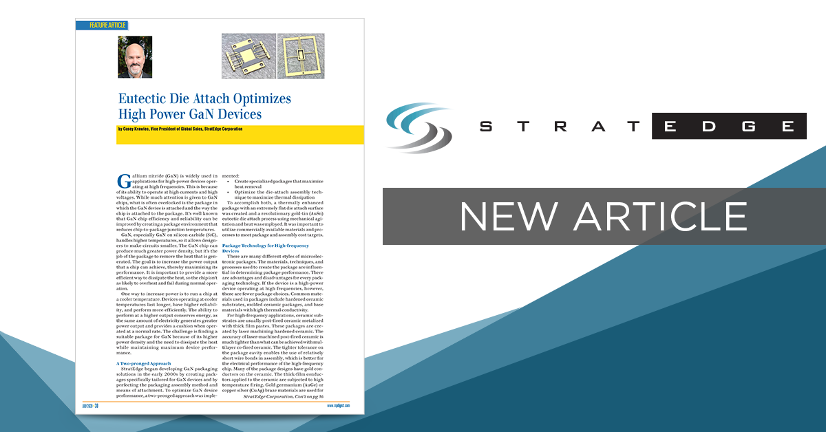

“The success of the package’s performance is dependent on the base material used, the quality of the package construction, and the attachment process. By creating a package environment that reduces chip-to-package junction temperatures, GaN chip efficiency and reliability can be improved,” explained Casey Krawiec, vice president of global sales at StratEdge. “StratEdge research shows that thermal dissipation can be further maximized by optimizing the die-attach assembly process.”

The paper “Eutectic Die Attach Optimizes High Power GaN Devices,” by Casey Krawiec, details how StratEdge’s post-fired ceramic package with a copper-molybdenum-copper (CMC) base, and its proprietary eutectic die attach method, results in a near void-free attachment that reportedly reduces junction temperatures by 20 degrees Celsius as compared to standard assembly methods using ceramic packages of alternate construction.

The paper is available in the July 2020 issue of Microwave Product Digest, and on the StratEdge website at http://stratedge.link/gan-devices-article.

For more information, contact StratEdge at info@stratedge.com, or visit our website at www.stratedge.com.

About StratEdge
StratEdge Corporation, founded in 1992, designs, manufactures, and provides assembly services for a complete line of high-frequency and high-power semiconductor packages operating from DC to 63+ GHz. StratEdge offers post-fired ceramic, low-cost molded ceramic, and ceramic QFN packages, and specializes in packages for extremely demanding gallium arsenide (GaAs) and gallium nitride (GaN) devices. Markets served include telecom for 5G, VSAT, broadband wireless, satellite, military, test and measurement, automotive, clean energy, and down-hole. All packages are lead-free and most meet RoHS and WEEE standards. StratEdge is ITAR registered and an ISO 9001:2015 certified facility located in Santee, California, near San Diego.
###
For more information contact:

Casey Krawiec
StratEdge Corporation
9424 Abraham Way, Santee, CA 92071
Email: c.krawiec@stratedge.com
Phone: +1.858.569.5000
Tricia McGough
AR Marketing, Inc. (agency)
+1.254.383.9700
Email: tricia@armarketinginc.com

