Contact: Tricia McGough, AR Marketing, Inc.
+1.254.383.9700; tricia@armarketinginc.com

FOR IMMEDIATE RELEASE
Photo snapshot at: https://www.stratedge.com/marty-daniel-interview.png
Video interview at: https://youtu.be/jjxORKRf0Ik
Make an Appointment with StratEdge at IMAPS International

StratEdge Reports A Strong Third Quarter
Attributed to early COVID-19 preparedness planning, participation in virtual events, and 5G infrastructure build-out
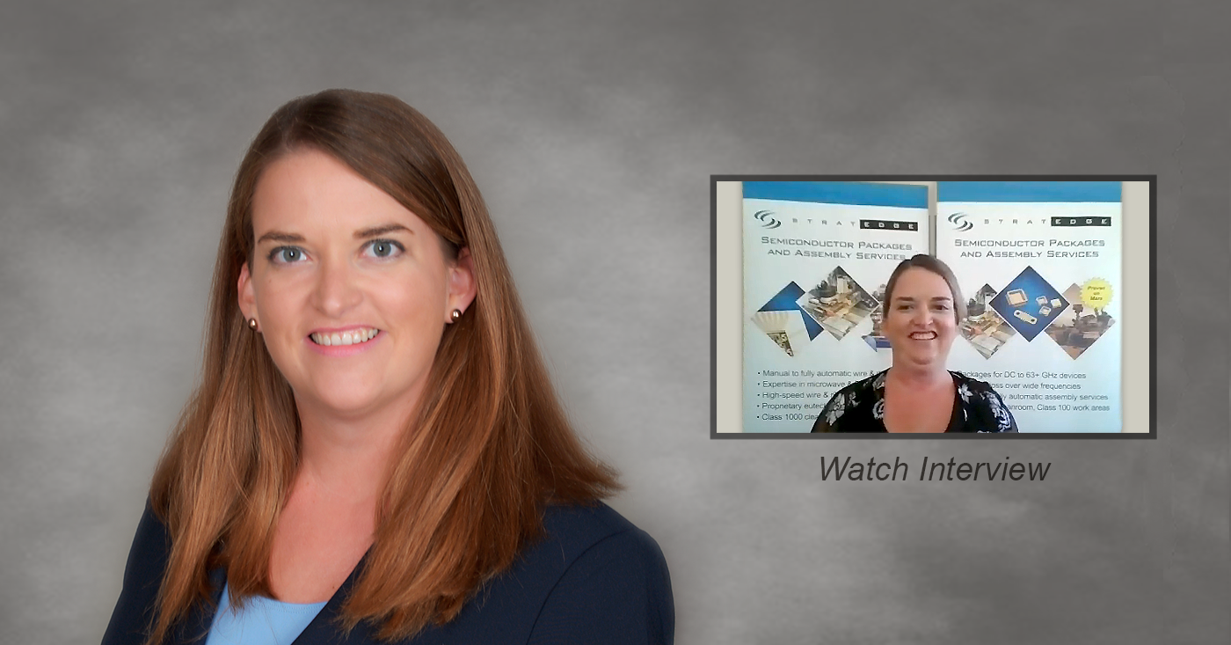Santee, Calif. — September 21, 2020 — StratEdge Corporation, leader in the design, production, and assembly of high-frequency and high-power semiconductor packages for microwave, millimeter-wave, and high-speed digital devices, announces a strong third quarter with a marked increase recently in requests for 5G-related quotes and contract orders when compared to the rest of the entire year. Ms. Marty Daniel, account manager at StratEdge, elaborates on the surge StratEdge is seeing for the 5G infrastructure build-out and how it relates to early COVID-19 preparedness planning while in an interview for a recent virtual event.

As an essential business, the management team at StratEdge began implementing immediate protections for COVID-19 preparedness at its new high-tech facility with ramped up assembly lines and Class 100 manufacturing area. One of the chemists on staff created a formula for making their own in-house hand sanitizer when supplies were hard to find. Several other staff members and their partners created extra masks for the manufacturing technicians and employees to wear. In addition to the masks and hand sanitizer, StratEdge also suspended all international and domestic travel for its employees as an added precaution.

“While sales and customer service processes have changed globally,” said Ms. Marty Daniel, “some customers have security protocols in place that can make communicating over public platforms very difficult. At StratEdge, we believe being flexible and accommodating is important in providing customers with total satisfaction.”

StratEdge’s management team recognized the changing needs and deployed Microsoft Teams early this year in anticipation of expanded needs. “That greatly improved our ability to meet with customers and key research and development staff members to discuss ongoing projects, including a rise in the 5G infrastructure build-out projects,” Ms. Daniel added.

You can catch up more with StratEdge by watching the full Zooming into SEMICON West interview available at https://youtu.be/jjxORKRf0Ik.

For more information, contact StratEdge at info@stratedge.com, or visit our website at www.stratedge.com.

About StratEdge
StratEdge Corporation, founded in 1992, designs, manufactures, and provides assembly services for a complete line of high-frequency and high-power semiconductor packages operating from DC to 63+ GHz. StratEdge offers post-fired ceramic, low-cost molded ceramic, and ceramic QFN packages, and specializes in packages for extremely demanding gallium arsenide (GaAs) and gallium nitride (GaN) devices. Markets served include telecom for 5G, VSAT, broadband wireless, satellite, military, test and measurement, automotive, clean energy, and down-hole. All packages are lead-free and most meet RoHS and WEEE standards. StratEdge is ITAR registered and an ISO 9001:2015 certified facility located in Santee, California, near San Diego.
###
For more information contact:

Casey Krawiec
StratEdge Corporation
9424 Abraham Way, Santee, CA 92071
Email: c.krawiec@stratedge.com
Phone: +1.858.569.5000
Tricia McGough
AR Marketing, Inc. (agency)
+1.254.383.9700
Email: tricia@armarketinginc.com

