Contact: Tricia McGough, TW Marketing
+1.254.383.9700; tricia@twmarketing.net

FOR IMMEDIATE RELEASE

Visit StratEdge at International Microwave Symposium (IMS) 2021 Booth 1014

Photo of SMK package and graph at: https://www.stratedge.com/smk

StratEdge SMK Surface Mount Packages Support DC to 26 GHz Devices
For VSAT, point-to-point, point-to-multipoint, and WiMax applications

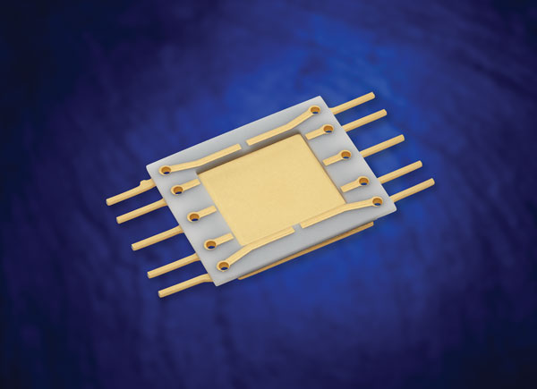
Santee, Calif. — April 27, 2021 — StratEdge Corporation, leader in the design and production of high-performance semiconductor packages for microwave, millimeter-wave, and high-speed digital devices, announces the release of its SMK Series surface mount DC to 26 Gigahertz (GHz) packages for test and measurement, VSAT, point-to-point, point-to-multipoint, and WiMax applications. These power packages have low insertion loss, good return loss, and excellent thermal properties.

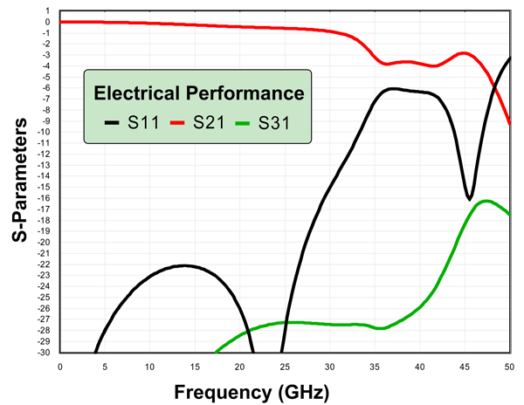
The SMK Series ceramic packages were designed to provide good electrical transition performance for die in the DC to 26 GHz range. See accompanying s-parameter plot displaying the 580495 package performance. The packages are made to provide wideband electrical performance and incorporate copper composite bases for enhanced thermal dissipation. These are true surface mount packages that allow automated assembly and soldering for high volume production of devices without sacrificing electrical and thermal performance. They are sealed with cup-shaped liquid crystal polymer lids with B-stage epoxy preforms that are provided with the lids.

“Plastic packages can’t handle the heat produced by die with high power dissipations,” said StratEdge vice president of Global Sales Casey Krawiec. “Our SMK series can handle both the thermal and electrical requirements of these devices and can be used in many high frequency applications because of their wideband performance. Our customers who have used them are extremely pleased with their performance and the convenience of them being surface mount.”
For more information about StratEdge, email info@stratedge.com, or visit our website at www.stratedge.com.

About StratEdge
StratEdge Corporation, founded in 1992, designs, manufactures, and provides assembly services for a complete line of high-frequency and high-power semiconductor packages operating from DC to 63+ GHz. StratEdge offers post-fired ceramic, low-cost molded ceramic, and ceramic QFN packages, and specializes in packages for extremely demanding gallium arsenide (GaAs) and gallium nitride (GaN) devices. Markets served include telecom for 5G, VSAT, broadband wireless, satellite, military, test and measurement, automotive, clean energy, and down-hole. All packages are lead-free and most meet RoHS and WEEE standards. StratEdge is ITAR registered and an ISO 9001:2015 certified facility located in Santee, California, near San Diego.
###
For more information contact:

Casey Krawiec
StratEdge Corporation
9424 Abraham Way, Santee, CA 92071
Email: c.krawiec@stratedge.com
Phone: +1.858.569.5000

Tricia McGough
TW Marketing (agency)
Email: tricia@twmarketing.net
Phone: +1.254.383.9700

