Contact: Tricia McGough, TW Marketing
+1.254.383.9700; tricia@twmarketing.net

FOR IMMEDIATE RELEASE
Photo at: https://www.stratedge.com/glass-sidewall.png

StratEdge to Present Glass Sidewall for Power Semiconductors and Ceramic Packages for 5G at IMAPS 2021 Live
Make an appointment to talk with our technical experts at Booth 409
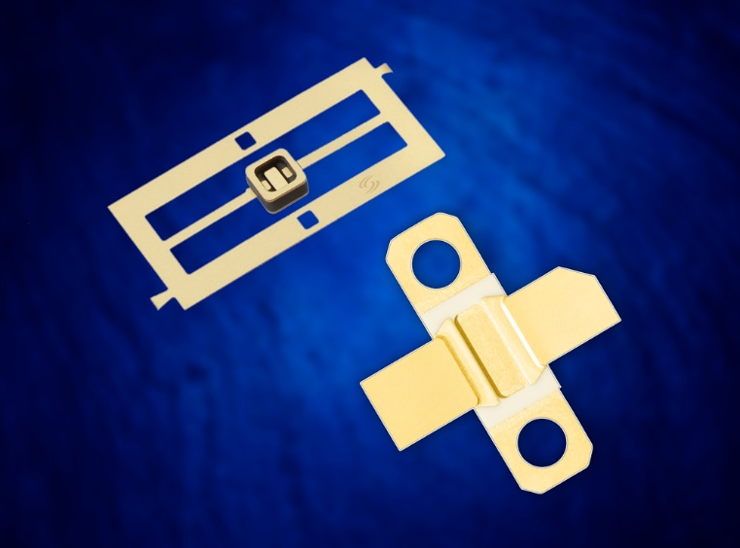Santee, Calif. — September 30, 2021 — StratEdge Corporation, leader in the design, production, and assembly of high-frequency and high-power semiconductor packages for microwave, millimeter-wave, and high-speed digital devices, announces that StratEdge technical experts will be available to discuss the best types of packaging and assembly services for devices at the LIVE International Symposium for Microelectronics (IMAPS) 2021 in San Diego, California.

StratEdge will showcase its newest line of small outline thermally enhanced alumina/glass sidewall packages for power semiconductors at IMAPS. The new line of packages can be used for silicon, silicon carbide, gallium nitride, and other compound semiconductors in power integrated circuit applications. Specific devices include amplifiers, discrete transistors, and diodes where greater than 0.5 Watt power is consumed.

StratEdge will also showcase packages used to support 5G infrastructure demands. The packages, most often used to protect high-power laterally-diffused metal-oxide semiconductor (LDMOS), gallium arsenide (GaAs), silicon carbide (SiC), and gallium nitride (GaN) devices, match standard outlines developed to support cellular base stations.

“GaN-on-SiC devices are frequently used in 5G base stations, but these devices can have extremely high power densities, which generate a tremendous amount of localized heat. StratEdge packages use copper-molybdenum-copper (CMC) bases to dissipate this heat, increasing the power output the chip achieves and enabling the device to operate at cooler temperatures so it lasts longer, has higher reliability, and performs more efficiently,” said Casey Krawiec, vice president of global sales.

For more information, contact StratEdge at info@stratedge.com, or visit our website at www.stratedge.com.

About StratEdge
StratEdge Corporation, founded in 1992, designs, manufactures, and provides assembly services for a complete line of high-frequency and high-power semiconductor packages operating from DC to 63+ GHz. StratEdge offers post-fired ceramic, low-cost molded ceramic, and ceramic QFN packages, and specializes in packages for extremely demanding gallium arsenide (GaAs) and gallium nitride (GaN) devices. Markets served include telecom for 5G, VSAT, broadband wireless, satellite, military, test and measurement, automotive, clean energy, and down-hole. All packages are lead-free and most meet RoHS and WEEE standards. StratEdge is ITAR registered and an ISO 9001:2015 certified facility located in Santee, California, near San Diego.
###
For more information contact:

Casey Krawiec
StratEdge Corporation
9424 Abraham Way, Santee, CA 92071
Email: c.krawiec@stratedge.com
Phone: +1.858.569.5000
Tricia McGough
TW Marketing (agency)
+1.254.383.9700
Email: tricia@twmarketing.net

