Contact: Tricia McGough, TW Marketing
+1.254.383.9700; tricia@twmarketing.net

FOR IMMEDIATE RELEASE
Photo at: https://www.stratedge.com/qfn-packages.png

StratEdge to Display New Broadband QFNs and Revolutionary Eutectic Die Attach for GaN Devices at IMAPS Virtual 2020
Make an appointment to talk with our technical experts
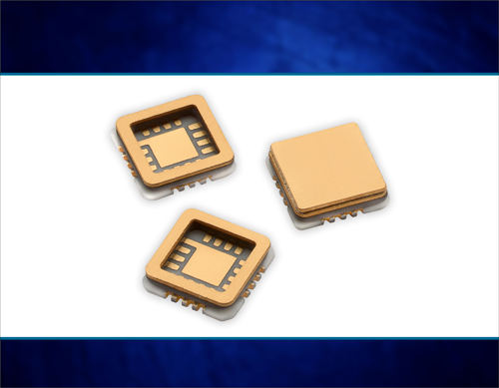
Santee, Calif. — October 5, 2020 — StratEdge Corporation, leader in the design, production, and assembly of high-frequency and high-power semiconductor packages for microwave, millimeter-wave, and high-speed digital devices, announces that StratEdge technical experts will be available to discuss the best types of packaging and assembly services for devices at the Virtual International Symposium for Microelectronics (IMAPS) 2020.

StratEdge will showcase its newly introduced line of hermetic, Ka-band, QFN packages for 5G and satellite applications at IMAPS. The thermally enhanced broadband packages have been designed for DC to 43 GHz. StratEdge offers post-fired ceramic, low-cost molded ceramic, and ceramic QFN packages, and specializes in packages for extremely demanding gallium arsenide (GaAs) and gallium nitride (GaN) devices.

"Much attention is given to GaN chips, but the package in which the GaN device is attached and the way the chip is attached to the package is often overlooked," explained Casey Krawiec, VP of global sales for StratEdge Corporation. "We have developed a proprietary eutectic die attach method that produces extremely thin, low-void bond lines between the device and package heat sink." StratEdge also provides the same service for die-on-tab. Learn more about the 6-micron thick, AuSn die attach process that produces greater than 96% coverage in StratEdge’s new white paper available at www.stratedge.com/imaps.

Also highlighted will be StratEdge Assembly Services and its new ISO 9001:2015 facility with a Class 1000 cleanroom, including Class 100 work areas with ESD control for performing sensitive operations.

Make an appointment and get more information at www.stratedge.com/imaps, or contact StratEdge at info@stratedge.com.

About StratEdge
StratEdge Corporation, founded in 1992, designs, manufactures, and provides assembly services for a complete line of high-frequency and high-power semiconductor packages operating from DC to 63+ GHz. StratEdge offers post-fired ceramic, low-cost molded ceramic, and ceramic QFN packages, and specializes in packages for extremely demanding gallium arsenide (GaAs) and gallium nitride (GaN) devices. Markets served include telecom for 5G, VSAT, broadband wireless, satellite, military, test and measurement, automotive, clean energy, and down-hole. All packages are lead-free and most meet RoHS and WEEE standards. StratEdge is ITAR registered and an ISO 9001:2015 certified facility located in Santee, California, near San Diego.
###
For more information contact:

Casey Krawiec
StratEdge Corporation
9424 Abraham Way, Santee, CA 92071
Email: c.krawiec@stratedge.com
Phone: +1.858.569.5000
Tricia McGough
TW Marketing (agency)
+1.254.383.9700
Email: tricia@twmarketing.net

